**1 Introduction**

**1.1 Purpose**

This project will support an NFL-centric social network, called “The Huddle”, where people can come together to talk all things football. The purpose is to provide a public online platform for users to discuss, debate and discover football.

**1.2 Scope**

*Goals and Objectives*

The goal is to create an application capable of hosting an online chat community in multiple simultaneous forums for football enthusiasts. The primary objective is to enable discussions among the network of registered users. Additional objectives are to provide NFL news and establish a basic level of privacy through privacy settings, options and limited logging of user activity.

*This Application Will Not*

The application will not log/store user conversations. The application news feed will not provide content unrelated to the NFL. Minors, users under the age of 13, will not be permitted to register. Those that do not consent to the User Agreement will not be permitted to register. The application will not allow users to modify the settings of other user’s profile page. Functionality will not allow users to forcefully remove other users from participating in any public board. History board listings shall not contain any record of private board participation.

*About Pages*

There will be 6 pages that users will experience: Login, Register, Profile, Main, Boards, and Chat. These pages outline the front end site architecture. The Login will be the first page users see when accessing the website, and will provide login or, for new users, initial direction to registration. The Register will establish the user account once required information is provided and a password is created. The Profile page will house the user information, favorites, and preferences. The Main page will house: an online friend listing, news feed, active board listing (private and public), favorites feed specific to the users self-proclaimed favorite teams/boards, and a link to the listing of active boards. The Boards page will house links to all currently existing public discussion boards the user may join. Finally, Chat page(s) will be populated for each discussion board the user joins.

*About Boards*

Private chat boards may be closed by the user which created the board. Public chat boards can be created by any user, but cannot be closed by any user. The board will remain active so long as the board continues to receive posts/messages from participating users. After 24 hours without any posts, user created boards will be expired.

*About Boards (cont.)*

The Main page will display a ‘Favorite Boards’ section the user has listed in the user’s Profile. Also, a ‘History’ will display the recent boards the user has visited.  A ’Boards’ button directs users to the Boards page which lists all active public boards. Search will also be available to help users find active boards in which they can engage.

The site will provide default public boards for: current weekly matchups, teams, and rivalries. Also, the user’s favorites, recent history, and active private boards shall be displayed.

**1.3 Definitions, acronyms, abbreviations**

*Jargon/Definitions*

Board: A messaging window in which users are able to post messages. Boards have a public or private status which determines visibility and access to all other users.

Handle: A user’s screen name that will be displayed in board posts in conjunction with that user’s preferred picture/avatar, and which precedes the user’s message/content.

Friends:  The site user(s) with which the primary user has established a connection easing future connections/messaging.

*Acronyms*

UA:  User Agreement is a legal agreement binding application users to the rules and expectations governing the continued use of the application and serves as the notification of legal expectations pertaining to use of the application.

NFL:  National Football League consists of 32 clubs divided into two conferences of 16 teams in each. Each conference is divided into four divisions of four clubs in each. During the regular season, each team is allowed a maximum of 53 players on its roster; only 46 of these may be active (eligible to play) on game days.

DM:  Direct Messaging is a private instant messaging functionality between two users.

**2 Specific requirements**

**2.1 External Interface Requirement - Sketches & Wireframe of potential design**

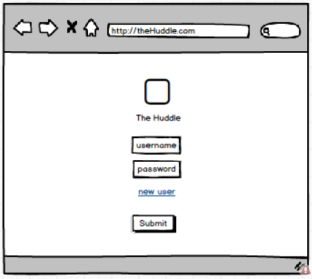 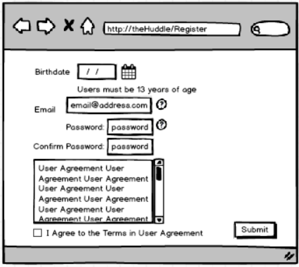 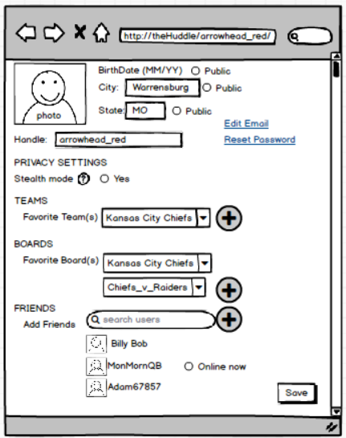

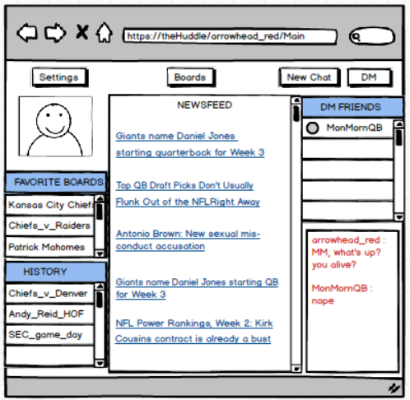 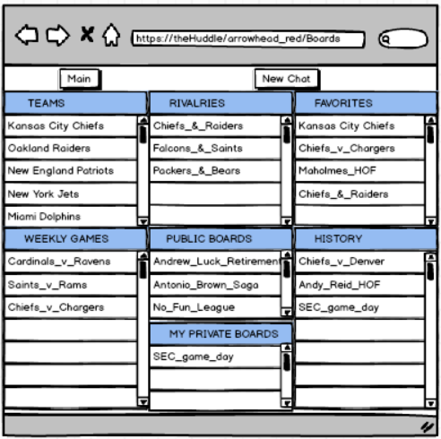

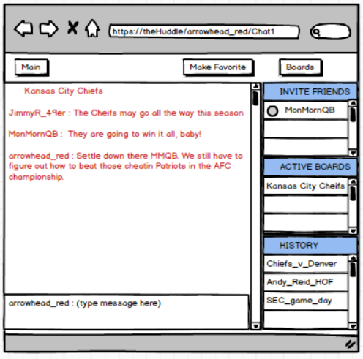 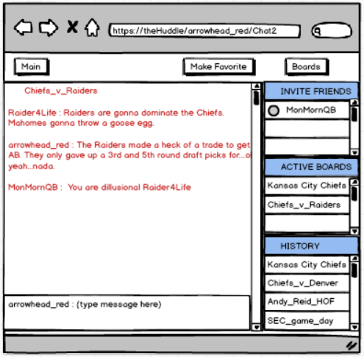

**2.2 Functional Requirement**

*Login*

The ‘Login’ field accepts the user name input. ‘Password’ field accepts and validates the user input password associated with the user name. Successful validation of both Login and Password keyboard input combinations directs user to the Main page. The validation is triggered by the user pressing the ‘Submit’ button, or pressing the Enter key, after filling in both ‘Login’ and ‘Password’ fields. ‘New User’ link takes the user to the Register page.

*Register*

Registration is for new users wishing to create a user account. Required account information is input on this page by the user, input from the user’s keyboard. The required field information includes: Birthdate (month and year), Email Address, Password, and User Agreement acceptance. Successful registration creates the user account and directs the user to the Profile page for additional user information. The Birthdate input field is used to validate the user is at least 13 years of age. Birthdates reflecting an age younger than 13 years will display a warning/reason and prevent the completion of establishing the account. The Email Address will be used as a preliminary user id and the email prefix will default as the user’s new handle. The Password fields allow users to establish an account password which meets the site requirements for strength/security. Passwords that fail to both match and meet the strength requirement will display a warning/reason and prevent the completion of establishing the account. The UA acceptance button will confirm acceptance to the UA. The ‘Submit’ button, upon successful completion of each of these steps, will create the user account and move the user to their Profile page.

*Profile*

The Profile page houses account specific information and preferences for the user, which the user inputs by keyboard. The required birthdate and email address from the Register page is visible here. Birthdate may not be altered, but a public visibility selection button allows this information to be visible to other site users, or not based on user preference. Links for ‘Edit Email’ and ‘Update Password’ are available on this page which direct the user back to the Register page where the user may update either/both. This page will also ask for users to provide additional data voluntarily which aids in the performance of the site: location data (City and State), handle, picture, privacy settings, favorite team(s), favorite boards, and friends. Picture defaults to a site logo, and can be updated to include user provided images. The user handle default is prefix of the provided email address, but can be updated on this page. Privacy settings will provide a stealth mode option which masks the user visibility from other site users. The user location should feed the default favorite team in the absence of a user selected team. Additional favorite teams may be added so users can easily follow multiple teams. Friends can be added via search by user handle. The ‘Save’ button will save any changes made by the user on the Profile page, and then direct the user to their Main page.

*Main*

The Main page is the central page for returning registered users after logging in. This page is broken into sections with each section containing different exploits for the site.

The user’s profile image will be displayed.

A section about boards will populate board links to both favorite boards and historical/ previously visited boards. The Favorite Boards section will import the users favorite boards if listed in the user’s profile, otherwise suggested boards may populate there. The History section will log the user’s recently visited boards allowing links for quick return. The board links shall open a Chat page for that board display and activate the user into that board.

The News section will import NFL related news content links into the center section of the page. Clicking on the news link will direct the user to the online content.

The DM Friends section contains a listing of user handles with which the user has made a prior friend connection. Only friends which are online will populate in the listing. By selecting the radio button next to a friend the user has an option to start a new chat with that friend, or DM that friend. Pressing the ‘New Chat’ button above, with friend(s) selected, shall start a new Chap page. Pressing the ‘DM’ button above, with friend(s) selected, shall start a new DM session with the selected friends which populates in the space below the friend listing. Clicking on the friend handle link will direct users to that friend’s profile page for viewing. The user may input messages on a keyboard and by pressing ‘Enter’ on the keyboard, the message will post in the DM field.

The ‘New Chat’ button shall create and open a public board for the user to then invite friends or wait for public users to join.

A ‘Boards’ button shall direct the user to the Boards page, an extensive listing of active boards with which the user may participate.

A ‘Settings’ button shall direct the user to their Profile page where they can update personal information, favorites, their profile image and other miscellaneous site settings.

*Boards*

The Boards page will house the links to existing active public boards for users to pick from and join. When a user selects the link to engage in a board, the board is opened in a CP. The boards are organized by sections: Teams, Weekly Game, Rivalries, General, and Private.

The ‘New Chat’ button shall create and open a public board for the user to then invite friends or wait for public users to join.

The ‘Main’ button shall direct the user back their Main page.

The Teams section will contain links to boards for each NFL team, allowing for users to discuss that particular NFL team.

The Weekly Game section will contain links to boards for each weekly matchup, allowing users to discuss that particular game.

*Boards (cont.)*

The Rivalries section will contain links to boards for major rivalries between two teams for the duration of the season.

The General section will contain links to boards for various active public boards created by users and open to all users.

The Private section will contain links to private boards in which the user has been invited to participate, or created.

*Chat Page (+n)*

The Chat page is a page which opens when a user joins a board. The page dedicates most of the available space to posting user generated messages/posts to display on the board. Three additional sections include the Friends, Active Boards, and Board History.

The Friends section lists the user’s friends. Selecting the radio button next to the friend’s name will send an invite link to that friend(s) to join the current board. Clicking on the username link will direct the user to that friend’s profile page.

The Active Boards section lists all board links the user is currently active, serving as a menu for moving between boards.

The History section lists all board links the user was active, serving as a menu for moving back to boards the user has previously visited.

The ‘Main’ button shall direct the user back their Main page.

The ‘Make Favorite’ button will update the user profile to include the current board in the users Favorite Boards section. This action would in turn include the current board in the user’s Main page listing of Favorite Boards.

A ‘Boards’ button shall direct the user to the Boards page, an extensive listing of active boards with which the user may participate.

As the user creates/joins subsequent discussion boards new Chat pages are created for each board. The user may input messages on a keyboard and by pressing ‘Enter’ on the keyboard, the message will post to the current board.

*Functionality Item Listing*

01.000 : Login page

01.010 : Username field / takes keyboard input

01.020 : Password field / takes keyboard input

01.030 : New User link / direct user to Register page

01.040 : Submit button / triggers username & password validation / direct to Main page

01.050 : theHuddle logo/icon / populates on page

02.000 : Register page

02.010 : Birthdate field / takes MM and YY inputs from keyboard, populates error message

*Functionality Item Listing (cont.)*

02.020 : Email field / takes inputs from keyboard

02.040 : Password field1 / verify strength standard(s) met

02.050 : Password field2 / matches password field1, populate error message

02.060 : User Agreement

02.070 : User agreement acceptance checkbox / error message if not checked

02.080 : Submit button / validation of all required conditions

02.090 : Submit button / create user object/account

03.000 : Profile page

03.010 : Birthdate received from Register / not editable

03.020 : City field

03.030 : State field or drop down box

03.040 : Handle field / receive email prefix from Register page / editable

03.050 : Edit Email link / direct back to Register page

03.060 : Reset Password link / direct back to Register page

03.070 : Public radio buttons for Birthdate/City/State

03.080 : Stealth mode radio button / mask online status of user / mask profile from (public) view

03.090 : Favorite Team section & dropdown box

03.100 : Favorite Team add dropdown box

03.110 : Favorite Boards section & dropdown box

03.120 : Favorite Boards add dropdown box

03.130 : Friends section

03.140 : Add Friends search field / search for users by handle

03.150 : Add Friends add button / adds searched friend to listing

03.160 : ‘Save’ button / update user object / profile is view only from other users

03.170 : User image / upload user file or link, default with logo

04.000 : Main page

04.010 : ‘Settings’ button /direct user to Profile page

04.020 : ‘Boards’ button / direct user to Boards page

04.030 : Profile pic visible

04.040 : Favorite Boards section

04.050 : Favorite board links from Profile page / direct to respective boards

04.060 : History section

04.070 : previously visited board links from user object / direct to respective boards

04.080 : Newsfeed section

04.090 : import news article links / filter based on contains criteria (‘NFL’, ‘Chiefs’, etc)

04.100 : DM Friends section

04.110 : populate friends links / direct to friend profiles pages

04.120 : radio button near friends / selectable

04.130 : ‘New Chat’ button / open new Chat page when pressed

04.140 : ‘New Chat’ button / if in conjunction to friend, invite friend(s) to new Chat page

04.150 : ‘DM’ button / activate DM in lower DM field / populate radio buttons

04.160 : DM field / takes input from keyboard once active

04.170 : radio select button near friends in DM Friends / if selected input messages can be sent

*Functionality Item Listing (cont.)*

05.000 : Boards page

05.010 : ‘Main’ button / directs user to Main page

05.020 : ‘New Chat’ button / open new Chat page when pressed

05.030 : Teams section

05.040 : Weekly games section

05.050 : Rivalries section

05.060 : Public boards section / lists all active public boards

05.070 : My Private Boards section / listing of active private chat pages

05.080 : Favorites section / listing of favorite links

05.090 : History section / listing of visited board links (excludes private boards)

05.100 : all board links populate / direct to respective chat page

06.000 : Chat page

06.010 : ‘Main’ button / directs user to Main page

06.020 : ‘Make Favorite’ button / adds current board to Profile page Favorite Boards

06.030 : ‘Boards’ button / directs user to Boards page

06.040 : Chat section / populates input from typing field

06.050 : typing field / takes input from keyboard, posts to Chat board with Enter key

06.060 : Active Boards section / lists all board links currently active

06.070 : History section / lists recently visited board links

06.080 : Invite Friends section / lists active friends

06.090 : radio button on friends / invites friend to board

06.100 : friend links / directs user to friend’s profile page

*Functionality Ranking*

***Establish Architecture***

01.000 : Login page

02.000 : Register page

03.000 : Profile page

04.000 : Main page

05.000 : Boards page

06.000 : Chat page(s)

01.010 : Username field / takes keyboard input

01.020 : Password field / takes keyboard input

01.030 : New User link / direct user to Register page

02.010 : Birthdate field / takes MM and YY inputs from keyboard, populates error message

02.020 : Email field / takes inputs from keyboard

02.040 : Password field1 / verify strength standard(s) met

02.050 : Password field2 / matches password field1, populate error message

02.070 : User agreement acceptance checkbox / error message if not checked

02.080 : Submit button / validation of all required conditions

02.090 : Submit button / create user object/account

***Establish Process for Creating/Maintaining Users***

01.040 : Submit button / triggers username & password validation / direct to Main page

03.010 : Birthdate received from Register / not editable

03.020 : City field

03.030 : State field or drop down box

03.040 : Handle field / receive email prefix from Register page / editable

03.050 : Edit Email link / direct back to Register page

03.160 : Save button / update user object / profile is view only from other users

***Enable Chat***

06.040 : Chat section / populates input from typing field

06.050 : typing field / takes input from keyboard, posts to Chat board with Enter key

04.130 : ‘New Chat’ button / open new Chat page when pressed

04.140 : ‘New Chat’ button / if in conjunction to friend, invite friend(s) to new Chat page

05.020 : ‘New Chat’ button / open new Chat page when pressed

05.100 : all board links populate / direct to respective chat page

***Expanding Chat***

04.020 : ‘Boards’ button / direct user to Boards page

06.030 : ‘Boards’ button / directs user to Boards page

03.110 : Favorite Boards section & dropdown box

03.120 : Favorite Boards add dropdown box

03.090 : Favorite Team section & dropdown box

03.100 : Favorite Team add dropdown box

04.040 : Favorite Boards section

04.050 : Favorite board links from Profile page / direct to respective boards

04.060 : History section

04.070 : previously visited board links from user object / direct to respective boards

*Functionality Ranking (cont.)*

***Expanding Chat (cont.)***

05.030 : Teams section

05.040 : Weekly games section

05.050 : Rivalries section

05.060 : Public boards section / lists all active public boards

05.070 : My Private Boards section / listing of active private chat pages

05.080 : Favorites section / listing of favorite links

05.090 : History section / listing of visited board links (excludes private boards)

05.010 : ‘Main’ button / directs user to Main page

06.010 : ‘Main’ button / directs user to Main page

06.020 : ‘Make Favorite’ button / adds current board to Profile page Favorite Boards

06.060 : Active Boards section / lists all board links currently active

06.070 : History section / lists recently visited board links

***Provide Friend Capabilities***

03.130 : Friends section

03.140 : Add Friends search field / search for users by handle

03.150 : Add Friends add button / adds searched friend to listing

04.110 : populate friends links / direct to friend profiles pages

04.120 : radio button near friends / selectable

06.080 : Invite Friends section / lists active friends

06.090 : radio button on friends / invites friend to board

06.100 : friend links / directs user to friend’s profile page

***Enable DM***

04.100 : DM Friends section

04.150 : ‘DM’ button / activate DM in lower DM field / populate radio buttons

04.160 : DM field / takes input from keyboard once active

04.170 : radio select button near friends in DM Friends / if selected input messages can be sent

***Finishing Touches***

03.060 : Reset Password link / direct back to Register page

03.070 : Public radio buttons for Birthdate/City/State

03.080 : Stealth mode radio button / mask online status of user / mask profile from (public) view

04.010 : Settings button /direct user to Profile page

03.170 : User image / upload user file or link, default with logo

04.080 : Newsfeed section

04.090 : import news article links / filter based on contains criteria (‘NFL’, ‘Chiefs’, etc)

04.030 : Profile pic visible

01.050 : theHuddle logo/icon / populates on page

02.060 : User Agreement